NE532 Project #1

# Problem Scenario

A geometry was simulated with a Cf-252 point source emitting 105 neutrons per second. This source was situated in the center of a 1 meter radius sphere of air, which was itself centered and enclosed in a cylinder of water. The goal was to determine the distribution of times at which the neutrons and photons emitted from the spontaneous fissions crossed the boundary of the sphere. Only particles leaving the sphere were counted.

# Calculations

First the research was performed to determine the parameters for the Watt spectrum. From Prof. Ragheb’s site [1], it was determined that the parameters for MCNP function -3 were 1.025 and 2.926, respectively.

For the fission gammas emitted by the Cf-252 the emission rate was back-calculated from the neutron emission rate:

$$\frac{{10}^{5}n}{s}×\frac{1fission}{3.76n}×\frac{8.13γ}{fission}=2.16×{10}^{5}\frac{γ}{s}$$

For the gamma energy distribution, the MCNP manual specified that energy bins be specified in terms of the CDF from the bottom of the energy bin to the top. The equation for the SP cards was therefore:

$$\int_{E1}^{E2}{P\left(E\right)dE}$$

with P(e) specified in the assignment as:

$$\left\{\begin{aligned}6.6, 0.1<E<0.6MeV \\ 20.2e^{-1.78E}, 0.6<E<1.5MeV \\ 7.2e^{-1.09E},1.5<E<10.5MeV\end{aligned}\right.$$

Further, energy bin widths were specified, allowing the substitution of values for E1 and E2. While this piecewise PDF is continuous (or nearly so), the varying bin widths did mean that more photons were generated in the 1.5-2.0 MeV bin than in the 1.45-1.5 MeV bin.

# Results

MCNP input and output files are included as attachments to this report for both the neutron and photon simulations.

## Photons

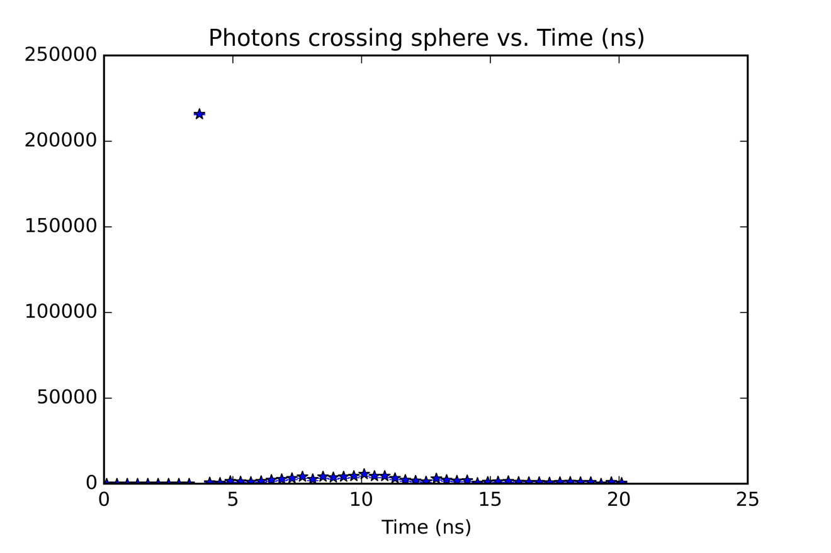

Figure : Distribution of photons crossing sphere (outbound) vs. Time

As can be seen in figure 1, most photons generated by the Cf-252 source between 3.3 and 3.7 ns. This corresponds to the naïve calculation of speed-of-light in vacuum transit from generation at the source to the sphere boundary, 1m away. Some (a very small fraction) interact with air molecules along the way, creating secondary photons that cross the boundary later.

## Neutrons

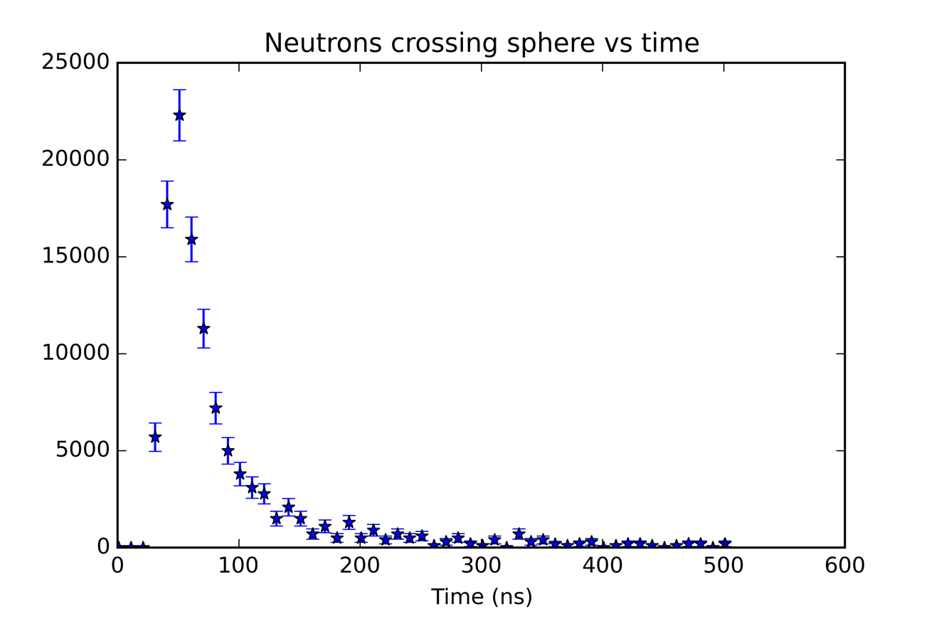

Figure : Neutrons crossing sphere vs. time

In the case of neutrons, the speed corresponds to the energy of the neutron. Therefore, even though few of the neutrons interact with the air molecules, they still show a distribution in the rate at which they reach the sphere boundary (as seen in figure 2).